**Minor project-1 Synopsis Topic**

**Home security system using IoT**



**Project Supervisor:**

**Ms. Monika Singh**

**Submitted to:**

**Dr. Juhi Gupta**

**Group Members:**

**Ayush Gupta 20102018(A1)**

**Divya Singh 20102019(A1)**

**Abstract**

Westernization of today's society has led to the increase in the number of small families while the gradual spread of living into the suburban areas has raised a significant concern in the security of the individuals. Although there are many security systems available in the market today, they are mostly expensive. The objective of the model described in this paper is to present a simple and low-cost design to make our homes smarter and safer. The Raspberry pi based framework built in this project comprises of PIR sensor, IR sensor, Piezoelectric sensor and Sound sensor which not only alerts an intruder action but also captures the images and recordings through a camera from the scene. An intrusion can be identified with the help of the above-mentioned sensors that can detect the presence of a person, temperature variations and sound at the location. In case of a deviant output from the above measurements, the owner of the house is immediately alerted through IoT. The rightful person receives a message on his phone immediately followed by images of the person causing the sceptical situation along with a captured video that gives a detailed picture of the happenings and will also serve as evidence for further investigations.

**IoT based Home Security System**

Introduction

Home security system is the most sort after mechanism to ensure the safety of valuables and to safeguard personal security as well. The development of burglar alert gadgets can limit the event of theft, while it can also identify and record suspicious trespassing. In places with high density like railroad stations and schools we can install face acknowledgment innovation which can identify hoodlums and suspicious people. This is a proactive technique that can control the event of the criminal occurrences and ensure the security of individuals and the property. To defeat the disadvantages of conventional burglar alarms, like infrared microwave indicators, glass break finder, microwave target movement locator, we propose the model presented in this paper.

**Proposed system:**

Whenever the thief enters in the house, and the steps on the floor immediately it is sensed by the sensor which passes on the signal to the raspberry pi controller. The controller in turn processes it to be valid signal and then moves the camera to the area where the movement was detected and then transmits it over the internet for the home owner to check the image.

**Work output:**



**Architectural flow:**

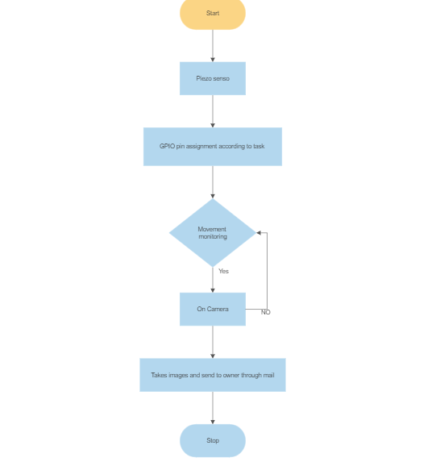

**Conclusion:**

The project "IOT Based Raspberry Pi Home Security System Using Motion Detector" has demonstrated how to get a fully functional embedded product developed from scratch. This incorporated the cross aggregation and organization of fundamental libraries, the arrangement of implanted Linux and distributed computing innovation. This system is highly recommended to home territory observation for example individual office lodge, bank storage space, stopping passage. At whatever point the movement is distinguished through. The fundamental Advantage of the undertaking is Easy to actualize, Minimal effort with High quality.

From improvement point of view we can add new features to existing system such as delay alarm to the system so that owner can switch off the system if anyone enters by mistake into the secured zone and we can add a photo recognition technology and have some pictures of the authorized users if they unknowingly steps into the zone. This is proposed further to reduce the possibility of the unwanted or false burglary alarm which in turn reduces the sensitivity of the system.

**References:**

Books:

* Internet of things with raspberryPi 3: leverage the power of raspberry Pi 3 and javascript to build exciting IoT projects by Rao, Manessh.

Papers:

* https://ieeexplore.ieee.org/document/9404551
* https://www.slideshare.net/irjetjournal/irjet-iot-based-anti-theft-detection-and-alerting-system-using-raspberry-pi